|  |
| --- |
| Automated Email Service  Guide |
| Creativity Pratik Bhattacharya  Hyderabad  Email – pratik.creativity@gmail.com |



## Deployment Guide

### **Pre-Requisites**

1. Azure Subscription
2. Visual Studio (2017)
3. GIT (Source Control)

## Create Azure Function

Follow the below steps to create an Azure Function

1. Go to Azure Portal (<https://portal.azure.com>)
2. Click on + Create a Resource
3. Choose Web from the left menu
4. Click on See All
5. Choose Function App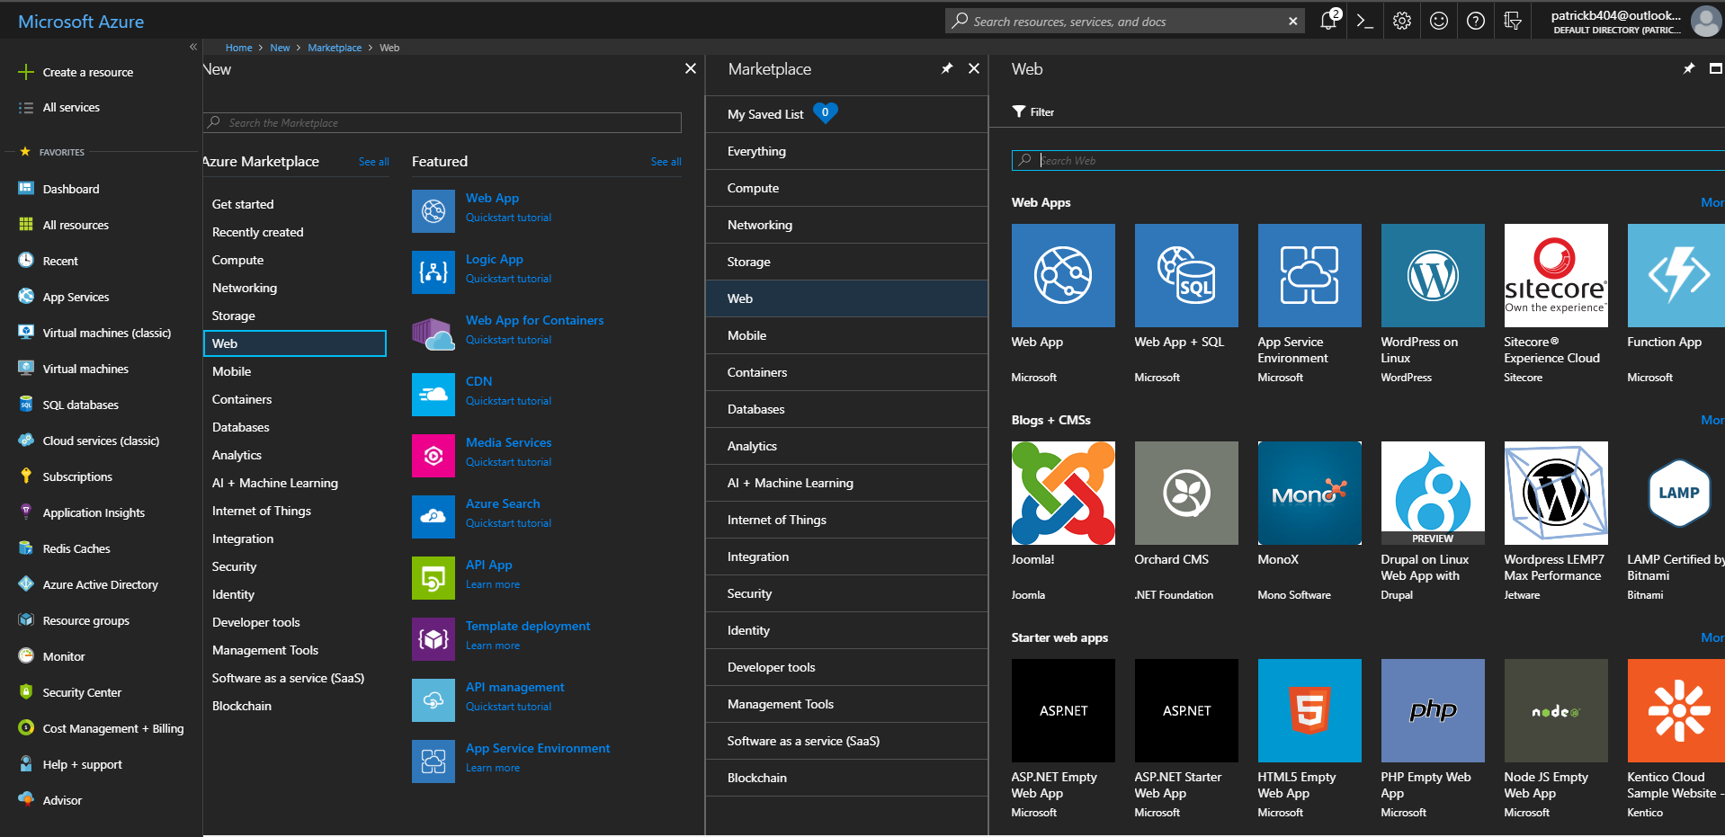
6. Click on Create
7. Provide details of the function App
   1. Give a unique name of the function app
   2. Choose your subscription
   3. If you want to deploy the function app to a new Resource Group then choose Create New under Resource Group section or choose an existing Resource Group
   4. Provide the Hosting Plan as “Consumption”
   5. Choose your location where you want to host the function app
   6. You will need a storage account associated with the function app. If you want to create a new Storage Account then choose Create New under Storage section, else choose your existing Azure storage account.
   7. Click on Create

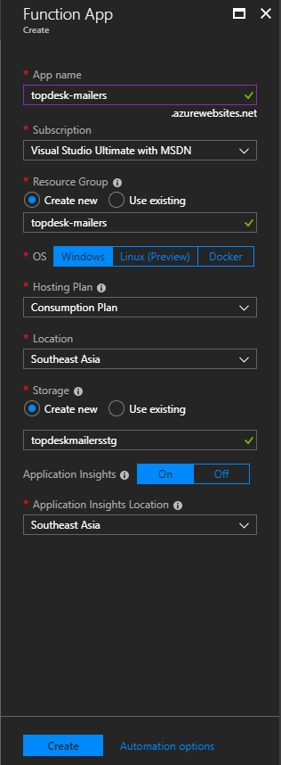

1. It might take around 1-2 minutes to get your resources provisioned

## Setup Environment Variables in Azure Function

For the function app to perform, the following environment variables need to set in the Function App service.

To setup an environment variable follow the below steps:

1. Open the function app from Azure portal (Go to All Resources and search by the name of the function app provided in the previous steps)
2. Click on Platform Features.

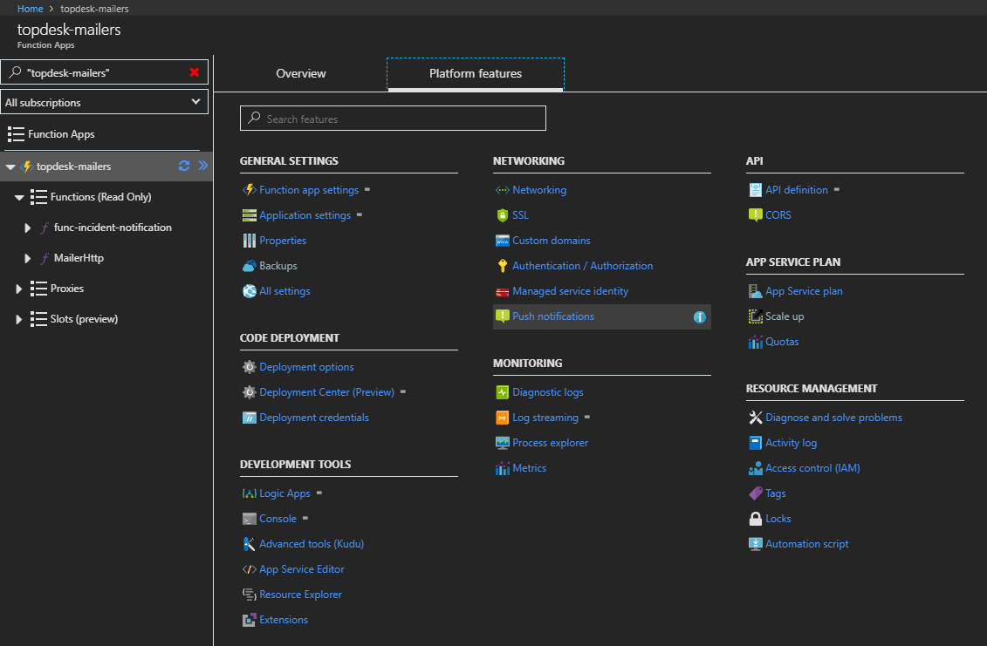

1. Click on Application Settings
2. Scroll down to the “Application Settings” section.
3. Click on “+ Add new setting” to add a new setting to the section.
4. Enter the name of the setting and the corresponding value

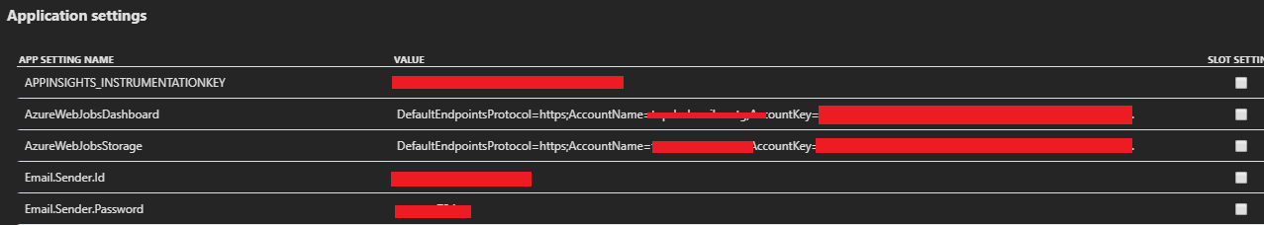

The settings that need to added is present in the “Topdesk Settings.xlsx” file. Please refer to that file and add all the settings in the Function App.

**Deploy Function App in Azure**

The function app needs to be deployed from Visual Studio.

**First Time Setup**

1. Ensure that your Function App is already create in your Azure subscription.
2. Open the Function App solution. Refer to this [link](https://docs.microsoft.com/en-us/azure/azure-functions/functions-develop-vs#check-your-tools-version) in case you are facing any issues in opening the Visual Studio.
3. Right-click on the Project and click on Publish.

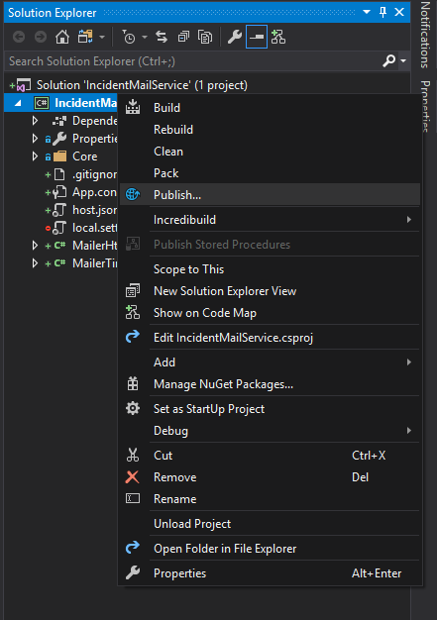

1. In the publish screen, choose Select Existing and click on Publish.

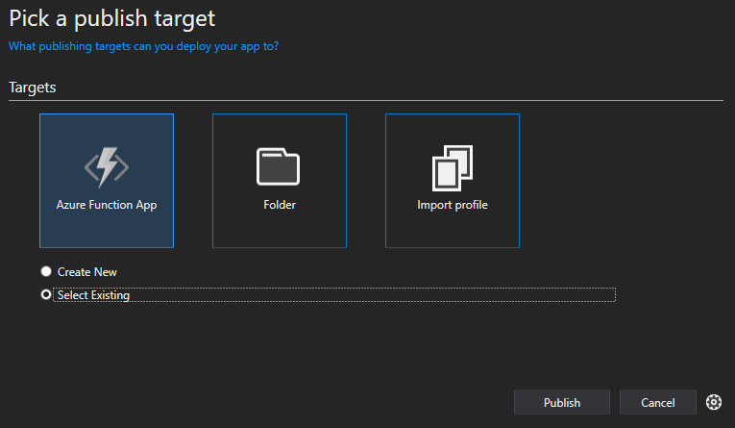

1. Choose your account and Azure subscription.
2. Choose the Resource Group and the App Service (Azure function that you have created in the subscription)

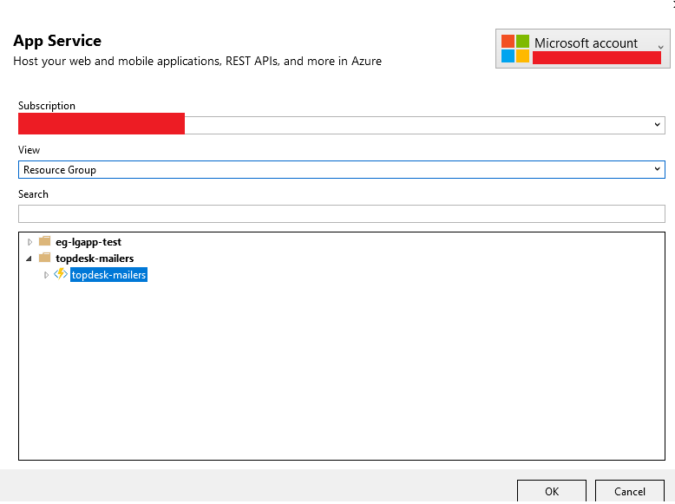

1. Click on OK.
2. Click on Publish and deployment should start.

**Continuous Deployment**

1. Right click on the Project
2. Click on Publish
3. In the Publish window, click on Publish.

